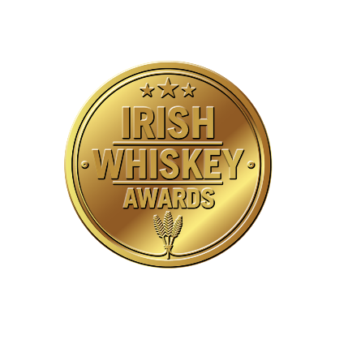
Irish Whiskey Awards 2025 Entry Form

Please Submit One Entry Form Per Whiskey Entered
(If you are submitting the entry form in writing, please use CAPITAL letters)
Product Name: ___________________________________________________________
Name of Producer: ___________________________________________________________
Name of Producer Contact: ___________________________________________________________
Email of Producer Contact: ___________________________________________________________
Category Entered (Please tick ✓ One)
Each Product Can Only Be Entered in One Category
Irish Whiskey:
☐ Irish Single Pot Still Whiskey (11 Years & Younger, inc Non Age Statement)
☐ Irish Single Pot Still Whiskey (12 Years & Older)
☐ Irish Single Malt Whiskey (11 Years & Younger, inc Non Age Statement) RRP Under €60
☐ Irish Single Malt Whiskey (11 Years & Younger, inc Non Age Statement) RRP €60 and Over
☐ Irish Single Malt Whiskey (12 - 15 Years)
☐ Irish Single Malt Whiskey (16 Years & Older) (We understand the whiskey in this category can be expensive so only 2 x 70cl bottles will be required for Judging (4 more if it wins))
☐ Irish Blended Whiskey Non-Age Statement RRP Under €50
☐ Irish Blended Whiskey Non-Age Statement RRP €50 and Over
☐ Irish Blended Whiskey (Age Statement)
☐ Irish Blended Whiskey (Limited Release)
☐ Irish Single Cask Whiskey (11 Years & Younger, inc Non Age Statement)
☐ Irish Single Cask Whiskey (12 Years & Older) (We understand the whiskey in this category can be expensive so only 2 x 70cl bottles will be required for Judging (4 more if it wins))
☐ Irish Cask Strength Whiskey
☐ Irish Single Grain Whiskey
☐ NEW Irish Whiskey — only distilleries open 3-6 years can enter and it must be distilled on site.
☐ Peated Irish Whiskey
Irish White Spirits & Irish Liqueurs:
☐ Irish Whiskey Liqueur
☐ Irish Cream Liqueur
☐ Irish Poitin
☐ Irish Vodka
☐ Irish Flavoured Vodka
☐ Irish Gin
☐ Other Irish Spirit (liqueurs, apple spirits, bitters, aperitifs, rum, etc)
Recommended Retail Price €____________
☐ Please confirm this whiskey will be available in November 2025 for retail
3 x 70cl Bottles (or equivalent volume — at least 2.8L if the product is in a smaller bottles or not yet released) of each entry must be delivered to Celtic Whiskey WAREHOUSE marked for the attention of Katie Gibson
☐ If Entry is successful and wins category we will require another 4 bottles for Awards Evening (or equivalent volume — at least 2.8L if the product is in a smaller bottles or not yet released).
We will require all samples by THURSDAY JULY 17 ^{TH}
Please email High Resolution image of each entrant to katie@celticwhiskey.com
Once completed, please send the form, along with your samples to Celtic Whiskey Shop’s Warehouse either by email or post, using the details below. Entries may also be handed into the WAREHOUSE marked for the attention of Katie Gibson.
Celtic Whiskey Limited
Unit 3
Naas Road Business Park
Muirfield Drive
Inchicore
Dublin 12
D12YN76
Ph: +353 1 6759744/ +353 1 912 3253

